**Case study

*Overview*

This is a case study of the sports-contact page me and a partner made for Grensesnitt. This is a project we chose at the start of our time here at SmartStudy.

In this case study you will see how the project started up and get an insight of solutions and difficulties we had through the project.

Me and my partner is happy with the end-result, though there is always room for improvements.

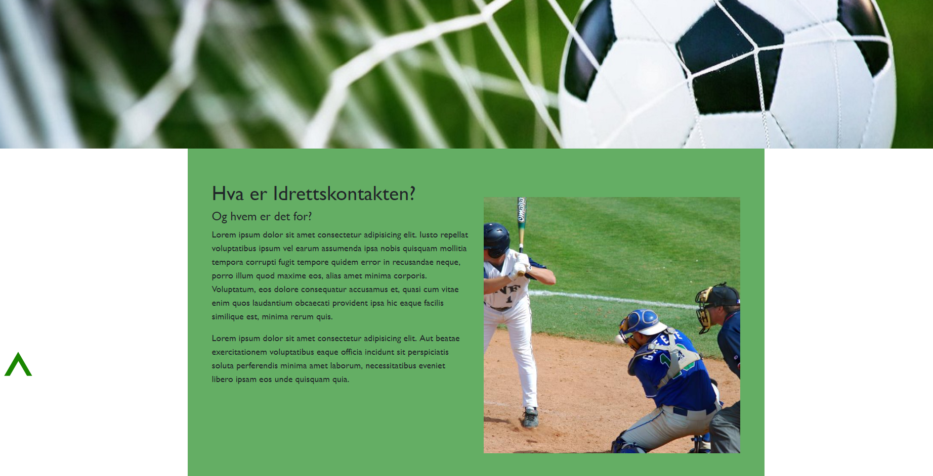

*Context and challenge*

1. Project background and description

In the first weeks there was visits by a handful corporate representatives, which presented their firm and how they worked. The main purpose for their visit was to give us a project that was to be worked on through our time here at SmartStudy. Then at the end of the course they were to return to see us present them the project they gave us. We ended up being 4 groups on 4 different projects, though there were 5 different ones, two was from the same company.

1. Problem/why

We got this project from the start to have a big project to work with alongside the main syllabus. There may be a job opening for the super lucky, so it is quite important to do a good appearance. The task here was to make a website for a fictional customer for them to present themselves, what they do and how they can get in touch with others at. The customer here is called “Idrettskontakten”, sports-contact in English. A voluntary organization which coordinates work amongst sport teams, with a goal to integrate refugees and asylum seekers in the teams.

1. Projectgoal and objectives

Me and my partner chose the Idrettskontakten project. This task is from a company called Grensesnitt, located in Bryne and which consists of two people. The website was to be a “one page site” with responsiveness to make it usable on phones and tablets. If we wanted to do more, we could implement the site to Wordpress, for the customer to easily publish their content there. Also, we were asked to embed a Twitter and Instagram feed. The twitter one was easy to add, while the Instagram proved to be more challenging. At the time writing we haven’t found a solution to how to add the IG feed, but we’re looking at it.

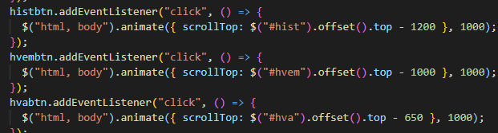

*Process and insight*

Me and my partner planned different technologies we were to use. We chose:

* HTML
* CSS
* JavaScript
* Node
* Spreadsheet library

A fast sketch was made first, which we fleshed out during the whole process. The final layout was finished after 2-3 weeks. It looks much the same now as it did then, with details and finishing touches along the way. We added a nice parallax effect with JS and an arrow for the user to press to get to the top.

*The Solution*

We initially went with a purple-themed page, like the example sheet Grensesnitt gave us. That changed to green fairly fast. There is a navbar at the top with logo to the left, while the navigation links are to the left. Under the navbar is a large cover image. Under the cover image the content is delivered, in this order:

1. About
2. Who is with us
3. Sports-contacts
4. History and experiences
5. *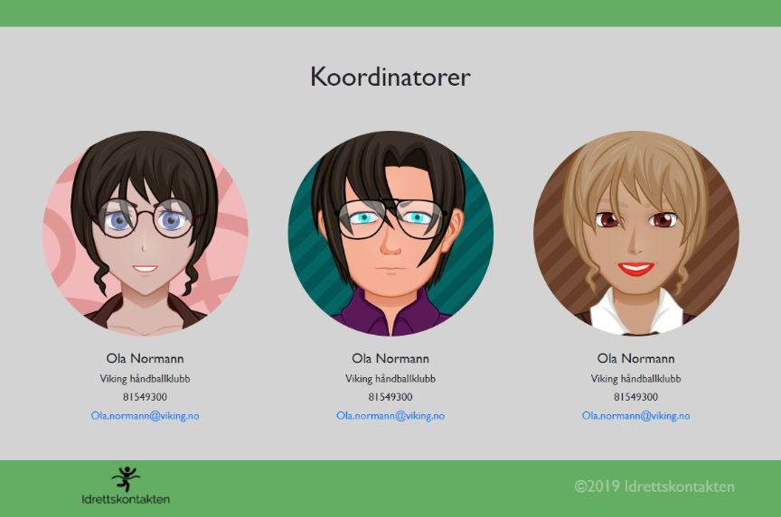*Contact us
6. Coordinators
7. Footer

*The Result*

Me and my partner is satisfied on how the page turned out. Though yet there is a minor annoyance with the difficulties with the Instagram integration. The feedback from our project-giver is still to come. But I’m confident they’ll be happy with the product. I will gladly put this project in my portfolio to show what I can make.

